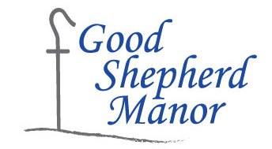
Day Instructor
Good Shepherd Manor is a nonprofit residential facility for 124 men with developmental and intellectual disabilities. Our picturesque 60 acre campus, which includes 14 modern group homes, is located 45 minutes South of Chicago on the outskirts of the historic town of Momence, Illinois.

We are currently accepting applications for the following positions:

Day Program Instructor

8:00am - 4:00pm Monday - Friday

Purpose:

To provide habilitation services and assist the resident in the development of skills in order to achieve their own personal maximum ability in accordance with the Individual Habilitation Plan (IHP). The Instructor is responsible for directing the skill training and active treatment within the assigned developmental, vocational, or senior classroom setting.

Experience:

Bachelor’s Degree in human services or a related field and one year of verifiable work experience with intellectually/developmentally disabled is required.

WE OFFER:
- Friendly work environment
- Competitive compensation
- Comprehensive benefits package

HOW TO APPLY: Apply online through Indeed.com or fax your resume to (815) 472-2160 or apply in person at 4129 North State Rt 1-17 Momence, IL 60954. No phone calls please.
Visit our website to get more acquainted with our Mission at Good Shepherd Manor, www.goodshepherdmanor.org.

Equal Opportunity Employer/Protected Veterans/Individuals with Disabilities

